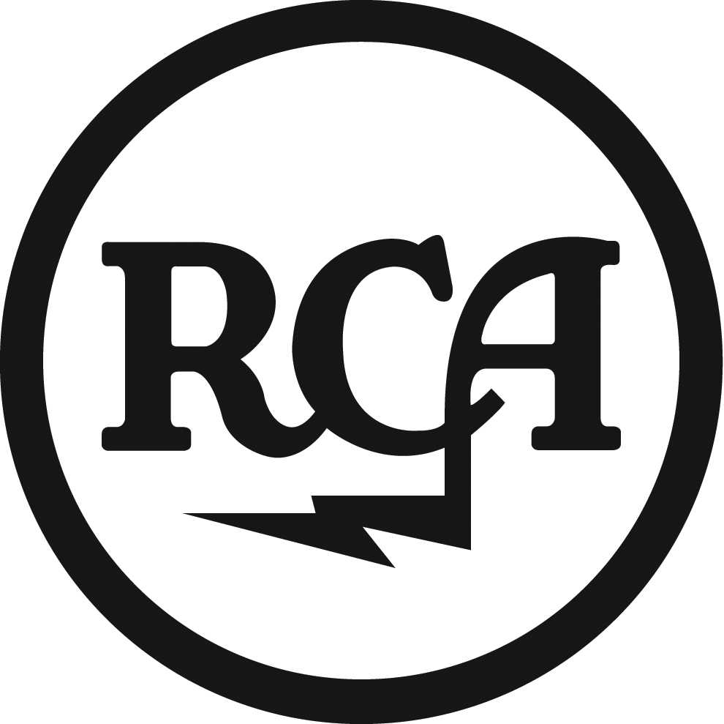

BREATHE CAROLINA

Single ‘BLACKOUT’
Released April 9, 2012

Denver based duo Breathe Carolina - David Schmitt and Kyle Even – are set to release Blackout as their first UK single through RCA records on April 9th. The song is taken from the album Hell Is What You Make It – which is slated for an April 16th UK release.

Blackout, a track for fans of Panic at the Disco who can appreciate the beats of LMFAO & Far East Movement, was last week certified gold in the US whilst climbing to #18 on the US Top 40 Chart. Originally released by Fearless Records last year, the band inked a deal with Columbia Records US in December 2011 who will be releasing the single and album worldwide in 2012.

Tracklisting:
1. Blackout
2. Blackout (Wideboys remix)
3. Blackout (Tommy Noble remix)
4. Blackout (Big Chocolate remix)
5. Blackout (Tek-One remix)

VEVO premiered a live performance of Blackout filmed at Breathe Carolina’s sold-out LA Troubadour show (click here to check it out: http://vevo.ly/zmgHVN), with more performances from the concert to launch in the weeks ahead. In addition, dates will be announced shortly for Breathe Carolina’s April co-headlining US tour with The Ready Set.

Hell Is What You Make It is only the latest chapter in Breathe Carolina’s story. Schmitt and Even started making music together in 2007 after their earlier bands broke up and they found themselves housemates in the suburbs of Denver. After setting up a MySpace page and gaining a bit of notoriety, they signed to Rise Records to release their debut album It’s Classy, Not Classic (September 2008). This led to a year of non-stop touring and a new deal with Fearless Records for their sophomore album Hello Fascination (2009).

For further information, please contact Nienke.klop@all-press.co.uk or on 0203 227 0430
or visit the band’s website at http://www.breathecarolina.net or follow them at https://twitter.com/breatheband

