SADE
‘Bring Me Home - Live 2011’
Live DVD/CD
Released 21st May 2012
Featuring a rare look behind-the-scenes of the critically acclaimed tour
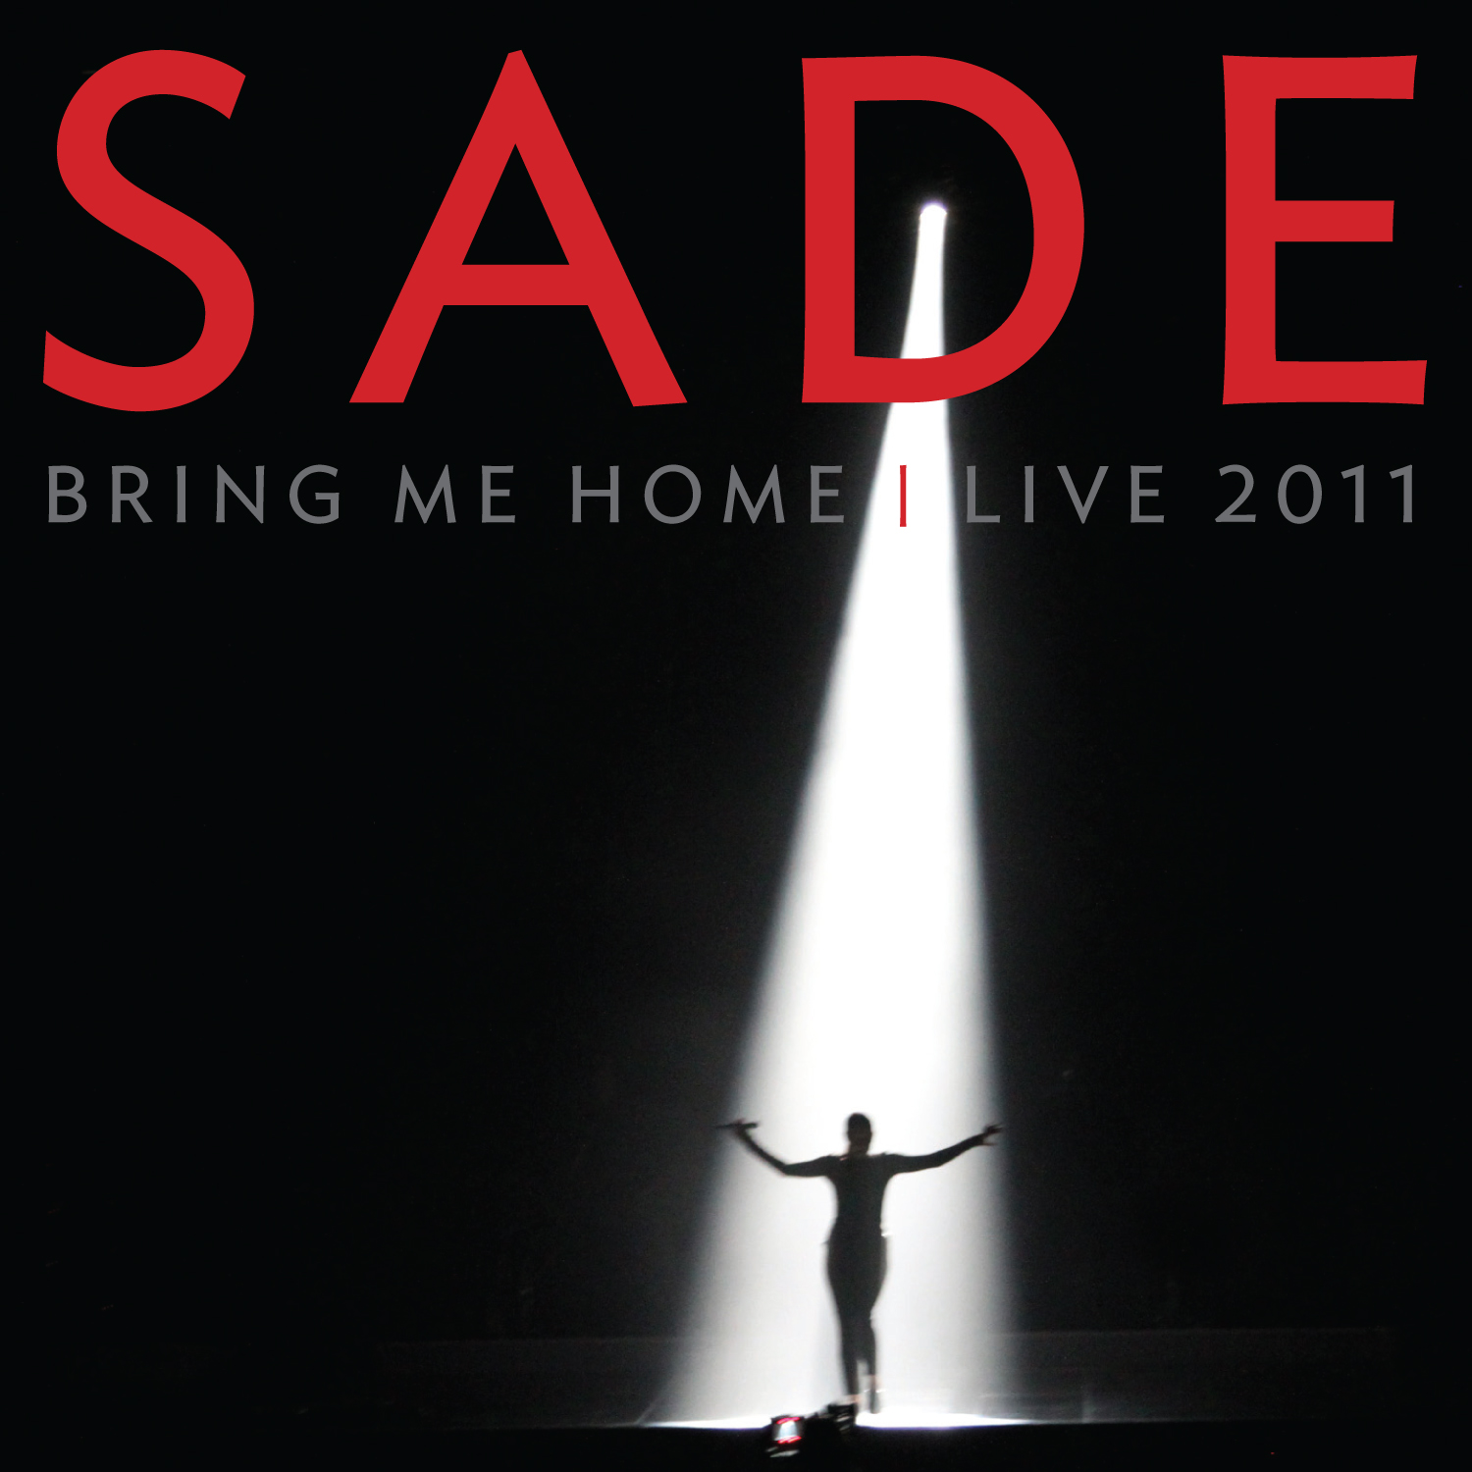

The Times: “Understated elegance remains Sade’s signature brand...
A sumptuous, polished, smartly conceived show... breathtakingly beautiful”
The Daily Telegraph: “Sade, still the ultimate Smooth Operator”
Evening Standard: “Nobody expresses adult sorrow and melancholy with such graceful pain [as Sade]”
The Metro: ”Even in the most mainstream of venues (O2 arena), this star is a rare gem.”
The Daily Star: “worth the wait.”
The Daily Mirror: “Sade’s performance is flawless.”
The Daily Mail: “Sultry, strutting and timeless”
The concert was hailed as “an uplifting, moving triumph” by the Evening Standard, and now Sade
will release their live DVD/CD and Blu-ray ‘Bring Me Home – Live 2011’ on 21st May.
After a hiatus of 18 years, Sade brought their long awaited concert to the UK, playing at the London O2 Arena, Birmingham NEC, and Manchester MEN Arena. The iconic band’s 106 date tour across America, Canada, Europe, South America and Australia, played to over 800,000 people and was the 6th highest grossing tour in North America for 2011. The spell binding concert received rave reviews from the world’s press.

During the American leg of the tour, acclaimed British director, Sophie Muller, captured the band’s two-hour visually stunning show for release on Blu Ray and DVD, with accompanying Live CD. Their 22 song concert, featuring hits from their 28 year repertoire, won the hearts of critics and was nominated for the music industry publication Pollstar for two awards: ‘Most Creative Stage Production’ and ‘2011 Major Tour of The Year Award’.

In addition to the concert, the elusive Sade Adu also grants fans rare glimpses of behind-the-stage scenes with a 20-minute documentary, also filmed by Sophie Muller, Sade’s creative director. It captures candid moments of Sade exclusively for this new release. The package also includes a short technical documentary by Stuart Matthewman, and outtakes from the crew.

Fans and critics alike have hailed the show for its intimate atmosphere, eye-catching production, and dazzling imagery, making this DVD/CD a must-have for the every Sade fan, and recent converts to this iconic British band alike.

Blu-Ray, and Live DVD tracklisting:
1. Soldier Of Love / 2. Your Love Is King / 3. Skin / 4. Kiss Of Life / 5. Love Is Found / 6. In Another Time / 7. Smooth Operator / 8. Jezebel / 9. Bring Me Home / 10. Is It A Crime / 11. Love Is Stronger Than Pride / 12. All About Our Love / 13. Paradise / 14. Nothing Can Come Between Us / 15. Morning Bird / 16. King Of Sorrow / 17. The Sweetest Taboo / 18. The Moon And The Sky / 19. Pearls / 20. No Ordinary Love / 21. By Your Side / 22. Cherish the Day

Live CD tracklisting:
1. Soldier of Love / 2. Skin 3. / Kiss of Life / 4. Love is Found / 5. In Another Time / 6. Jezebel / 7. All About Our Love / 8. Paradise - Nothing Can Come Between Us / 9. Morning Bird / 10. The Moon and the Sky / 11. No Ordinary Love / 12. By Your Side / 13. Cherish the Day

Throughout their twenty-eight year career, Sade have enjoyed phenomenal success both in the UK and internationally. Since the release of their debut album, Diamond Life in 1984, the band have seen all six of their studio albums land in the Top 10 on Billboard’s Top 200 Album Chart, selling more than 55 million albums worldwide to date. They’ve been nominated for American Music Awards, MTV Video Music Awards, won a Brit Award for Best Album for Diamond Life, and four Grammy Awards – first in 1986 for Best New Artist, then in 1994 for Best R&B Performance By A Duo Or Group for No Ordinary Love, Best Pop Vocal Album with Lovers Rock in 2002, and again for Best R&B Performance By A Duo Or Group in 2010 for Soldier of Love.

The live DVD is available on pre-order from http://www.amazon.co.uk/ now.
For more information, please contact Nienke Klop at Nienke.klop@all-press.co.uk /020 3227 0430
Or visit the band’s website at www.sade.com

