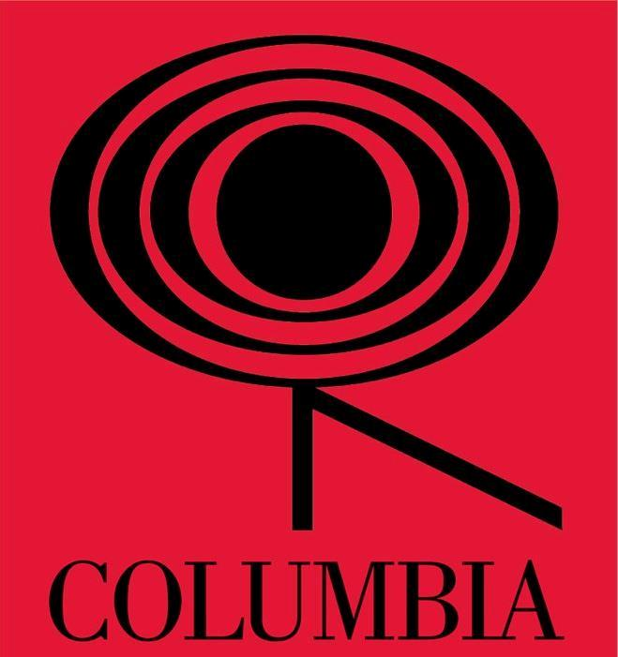

DON DIABLO
‘Silent Shadows’
Single
Released April 30th

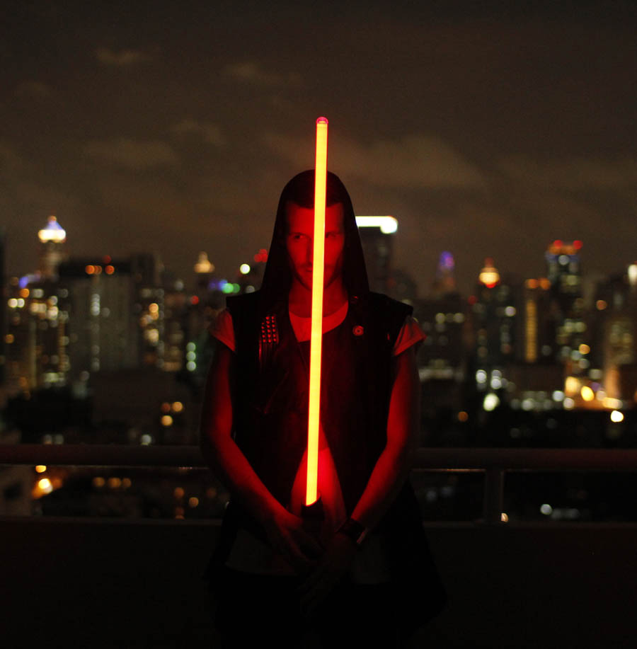

‘Don Diablo: a future superstar’ Pete Tong

Dutch DJ/Producer, and recent Columbia records signing, Don Diablo is set to release his debut single Silent Shadows on April 30th.

A genre-bending producer, and known for his trademark use of his own vocals as instruments throughout his productions, Diablo’s skills have been honed producing tracks as well as remixes for, amongst others, Example, Gorillaz, Tinie Tempah, Cassius, Fatboy Slim, and Iggy Pop. Throughout the past two years, Don has had massive support from music blogs all over the world resulting in numerous #1 spots on Hype Machine and even their coveted ‘Most Blogged Artist’ spot. Kanye West also praised Don's visual talents by posting one of Don's self-directed music videos on his blog.

Don’s tracks have also appeared on tv shows like CSI:NY and games like Need for Speed, and most recently, one of his collaborations (with Diplo, on his Mad Decent label) was used in a worldwide Blackberry campaign.

Don, who was named after Don van Vliet, a.k.a. Captain Beefheart, says about the single: "I worked on the music for "Silent Shadows" with the guys from Noisia and came up with the lyrical concept with Swedish vocal talent Mirou (Marlene Strand). I was also really happy to be able to work with L.A. based music video director Alistair Legrand on a very dark video, which is unlike anything I have ever done before. I can't wait to share more of the new music and collaborations with the world this year."

Track listing:
1. Silent Shadows (Original) 2. Silent Shadows (Quilnez remix) / 3. Silent Shadows (Mind Vortex Remix) / 4. Silent Shadows (Preditah Remix) / 5. Silent Shadows (Keljet Remix) / 6. Silent Shadows (VIP mix) / 7. Silent Shadows (Drive By Disco Mix) / 8. Silent Shadows (Short edit) / 9. Silent Shadows (instrumental)

As a DJ Don is best known for his enthusiastic four deck DJ shows that have rocked festivals and clubs around the globe including at Glastonbury, Creamfields, Space (Ibiza) and the Australian Summadayze & Future Music festival tours alongside Mark Ronson, Pendulum, MGMT and many others.

For more information, please contact Nienke Klop at Nienke.klop@all-press.co.uk /0203 227 0430
Or visit Don’s website at www.dondiablo.com / follow his blog at www.dondiablog.com

