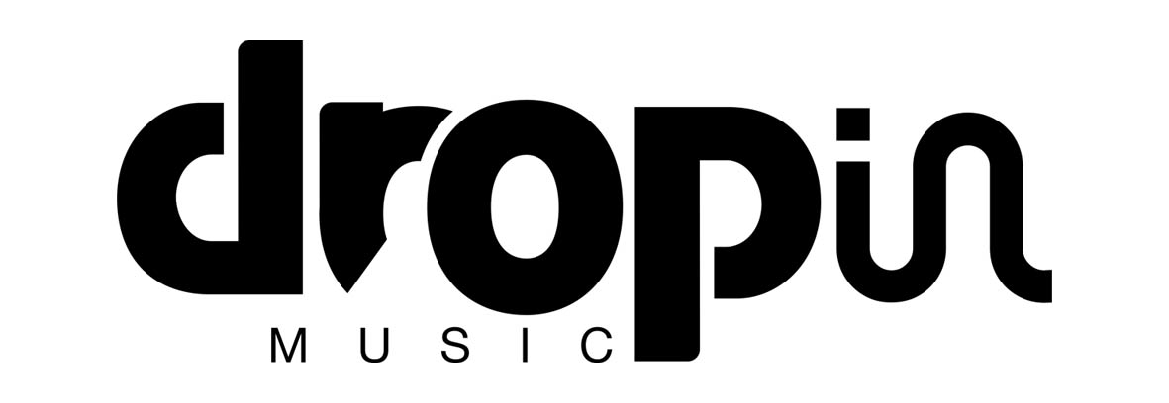

CHARLOTTE O’CONNOR
Single
ADDICTED
Released May 14th

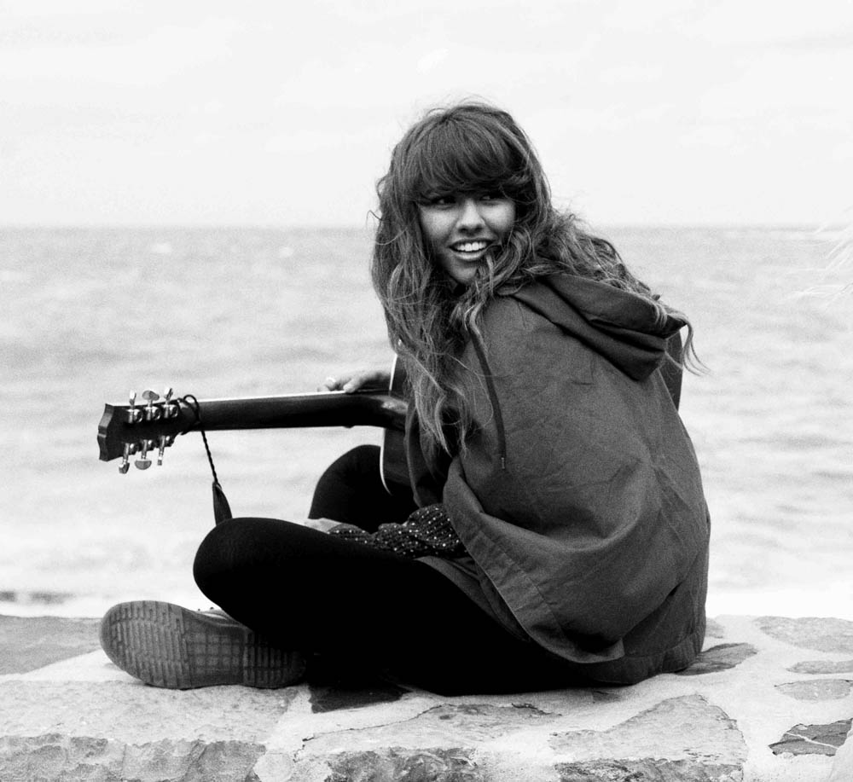
‘Not just a pretty face – she’s got a voice to match’ Bliss
‘Charlotte delivers the sort of West Coast-tinged nugget Norah Jones is famous for’ – Daily Star Playlist
‘..her breathy delivery and quietly powerful vocals and hooks land some unexpectedly powerful punches’ - OK Hot Star
‘mesmerising’ - Sun SFTW
‘Powerful, mesmerizing and heartbreaking all at the same time’ - Look

Charlotte O’Connor is set to release the single ‘Addicted’ via Drop In Music (Quiksilver records) on May 14th 2012. This will be the first single taken from Charlotte’s forthcoming as yet untitled EP, set for a late summer / early autumn release.

Having finally been able to release her debut album ‘For Kenny’ in March of 2012, Charlotte has been eager to get back into the studio to record some of the new tracks she has written since finishing For Kenny 4 years ago. When she is not playing shows, Charlotte will be holed up in Quiksilver’s recording studio in Biarritz, a stones throw from the beach.

Despite her folky, soulful sound, Charlotte admits that her musical influences are far reaching. Growing up in Blackburn with a half-Malawian/half-Indian mum and an Irish father, she was exposed to all kinds of sounds. “My dad was in the Merseybeats for a while and he was even on Top of the Pops. He was very involved in the Liverpool music scene, so he has taught me a lot. And on my mum’s side were the old soul records she used to love playing. So the house was always filled with music, be it James Taylor, Aretha Franklin or Talking Heads. I was also in love with Freddie Mercury when I was younger! He was my idol, and still is. I take so many different genres on board, but my own sound is romantic and fun, with a lot of energy.“ She continues: ‘Addicted is one of my favourite tracks to play live, and is about me liking somebody but not wanting to admit it' Charlotte filmed the video for Addicted in one day, across her hometown.

Tracklisting:
1. Addicted

With a presence on stage powerful beyond her 21 years, Charlotte has already supported the likes of Newton Faulkner, James Morrison, The Script and Lissie, and will be embarking on an acoustic full UK tour around the release of Addicted in May 2012. And you can also catch her live on the following dates:
April
Sun 15 London Broken Folk
Thu 26 Halifax The Puzzle Hall Inn
May
Thu 4 London Broken Folk
Fri 25 Brighton RNLI session
June
Thu 7 London Broken Folk
Fri 8/9/10 Inverness Rockness Festival
Sat 16 South Wales Beachbreak Live
July
Sat 7 Dorset Lush Festival
Sat 14 Hereford Rock The Farm Festival
Sun 22 London Broken Folk
August
Sat 11 Newquay Boardmasters
Sat 18 North Wales Glass Butter Beach fest
September
Fri 28 London Broken Folk

For further information, please contact Nienke.klop@all-press.co.uk or on 0203 227 0430
or visit Charlotte’s website at http://charlotteoconnor.com/

